**Nodejs Assignments**

Introduction to Node.js

Theory Assignment:

**• Write an essay on the history and evolution of Node.js, discussing its architecture and key features**.

### =>The History and Evolution of Node.js: Architecture and Key Features

Node.js, introduced by Ryan Dahl in 2009, revolutionized server-side programming by enabling JavaScript to run outside the browser. Built on Google’s V8 JavaScript engine, Node.js addressed inefficiencies in traditional server-side technologies by providing a non-blocking, event-driven framework for scalable applications. Dahl’s vision was to create a platform that handled asynchronous operations efficiently, which led to its rapid adoption.

**Architecture**

Node.js is centered around an **event-driven, non-blocking I/O model**, allowing it to handle thousands of concurrent connections with minimal resource usage. Key components of its architecture include:

1. **Event Loop**: A single-threaded mechanism for managing asynchronous tasks efficiently.
2. **Libuv**: A C-based library that powers its cross-platform asynchronous I/O capabilities.
3. **V8 Engine**: A high-performance engine that compiles JavaScript into machine code.
4. **Modules**: Node.js promotes modularity with a built-in module system for reusable code.

**Key Features**

1. **Asynchronous and Non-Blocking I/O**: Ensures high performance and scalability.
2. **Cross-Platform Compatibility**: Runs on Windows, macOS, and Linux.
3. **npm (Node Package Manager)**: Provides access to a vast ecosystem of libraries.
4. **Real-Time Application Support**: Ideal for apps like chat or streaming services.
5. **Single Language**: Uses JavaScript on both client and server sides, simplifying development.

**Evolution**

Since its creation, Node.js has evolved through regular updates, improved security, and a robust ecosystem. Its governance by the OpenJS Foundation has ensured sustained growth. Frameworks like Express.js and its adoption by tech giants like Netflix and Uber highlight its impact.

Node.js remains a cornerstone of modern web development, thanks to its efficiency, scalability, and thriving community. Its influence on server-side programming continues to shape the future of software engineering.

**• Compare Node.js with traditionalserver-side technologies like PHP and Java.**

• **Execution Model**

* **Node.js**: Non-blocking, event-driven, and asynchronous, enabling efficient handling of multiple concurrent connections with a single thread.
* **PHP**: Synchronous and blocking by default, though asynchronous programming can be achieved with additional libraries. Each request typically spawns a new thread or process, which can be resource-intensive.
* **Java**: Traditionally multi-threaded, using a thread-per-request model. Modern frameworks like Spring Web Flux support non-blocking I/O, similar to Node.js.

• **Language**

* **Node.js**: Uses JavaScript, allowing developers to use a single language for both client and server-side development.
* **PHP**: Dedicated to server-side scripting, primarily used for web development.
* **Java**: A general-purpose, strongly-typed language, suitable for enterprise-level and multi-platform applications.

• **Performance**

* **Node.js**: High performance for I/O-intensive tasks due to its non-blocking architecture.
* **PHP**: Slower for handling concurrent requests but performs well in single-threaded use cases.
* **Java**: Offers excellent performance for compute-intensive tasks, with strong multi-threading capabilities.

• **Ecosystem**

* **Node.js**: Features npm, a vast package manager for libraries and tools.
* **PHP**: Relies on Composer for package management, which is less extensive than npm.
* **Java**: Uses Maven or Gradle, providing a mature and robust ecosystem for enterprise applications.

• **Scalability**

* **Node.js**: Ideal for real-time applications and microservices due to its event-driven model.
* **PHP**: Less suitable for large-scale, concurrent applications without significant optimization.
* **Java**: Highly scalable, particularly for enterprise and distributed systems.

• **Use Cases**

* **Node.js**: Real-time apps (chat, gaming), APIs, and lightweight microservices.
* **PHP**: Content management systems (e.g., WordPress), small to medium-sized websites.
* **Java**: Enterprise-level applications, financial systems, and Android development.

**Practical Assignment:**

• Install Node.js on your local machine and create a simple "Hello World" application. Include instructions for installation and running the application.

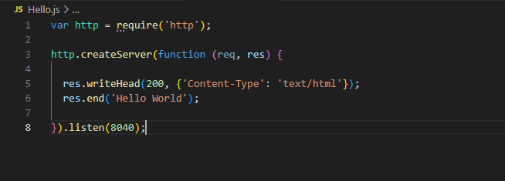

Output:

